SQL AND JAVA CONNECTION ASSIGNMENT

# JAVA CODING:

package sqlconnect;

import java.sql.Connection; import java.sql.DriverManager; import java.sql.ResultSet; import java.sql.SQLException; import java.sql.Statement;

public class assignment {

public static void main(String[] args) throws ClassNotFoundException, SQLException {

*InsertQuery*(); *selectQuery*();

}

static void InsertQuery() throws ClassNotFoundException, SQLException

{

Class.*forName*("com.mysql.cj.jdbc.Driver"); System.***out***.println("Driver Class Loaded");

Connection con=DriverManager.*getConnection*("jdbc:mysql://localhost:3306/ATM","root","86100@Viswa");

System.***out***.println("Connection Object created"); Statement s=con.createStatement(); System.***out***.println("Statement Object created");

int r=s.executeUpdate("insert into details(namess,aadhar,pan) values(\"Helen\",23456,23456);");

System.***out***.println("Value Inserted");

}

static void selectQuery() throws ClassNotFoundException, SQLException

{

Class.*forName*("com.mysql.cj.jdbc.Driver"); System.***out***.println("Driver Class Loaded");

Connection con=DriverManager.*getConnection*("jdbc:mysql://localhost:3306/ATM","root","86100@Viswa ");

System.***out***.println("Connection Object created"); Statement s=con.createStatement(); System.***out***.println("Statement Object created");

ResultSet rs=s.executeQuery("select * from ATM.details;"); while(rs.next())

{

System.***out***.println(rs.getString(1));

}

}}

# OUTPUT:

Driver Class Loaded Connection Object created Statement Object created Value Inserted

Driver Class Loaded Connection Object created Statement Object created 1

2

3

4

**SCREENSHOTS:**

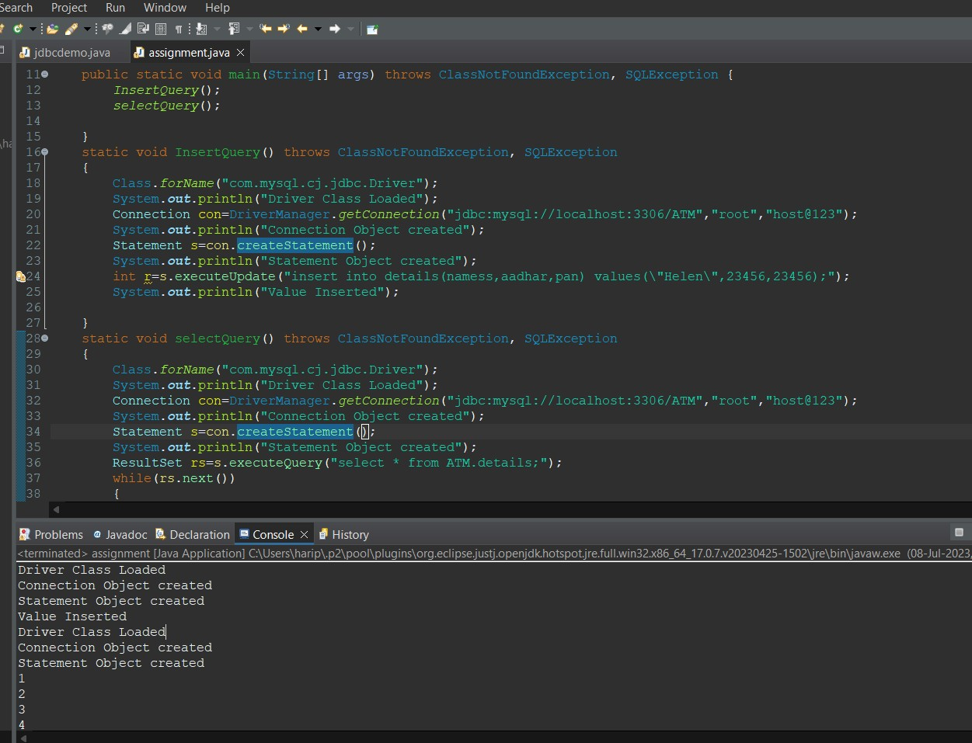

# DATABASE BEFORE ADDING:

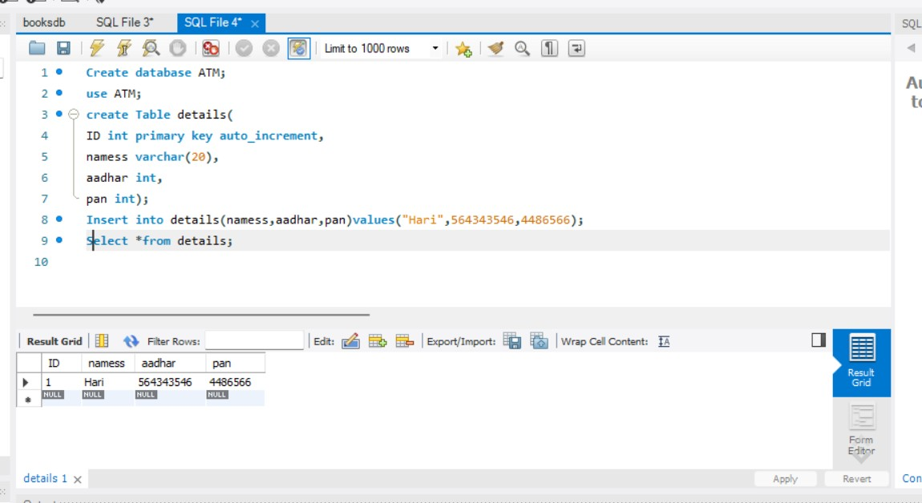

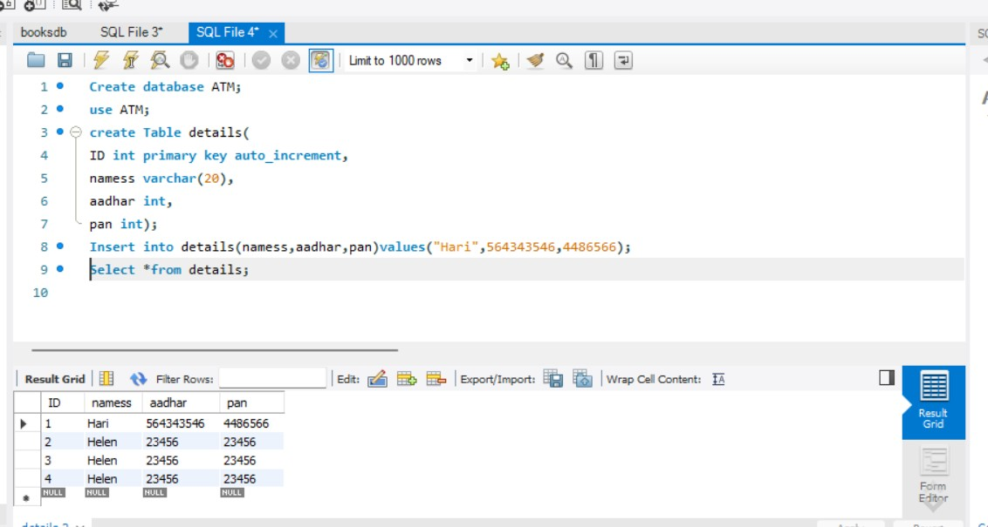**DATABASE AFTER ADDING JAVA CODE:**